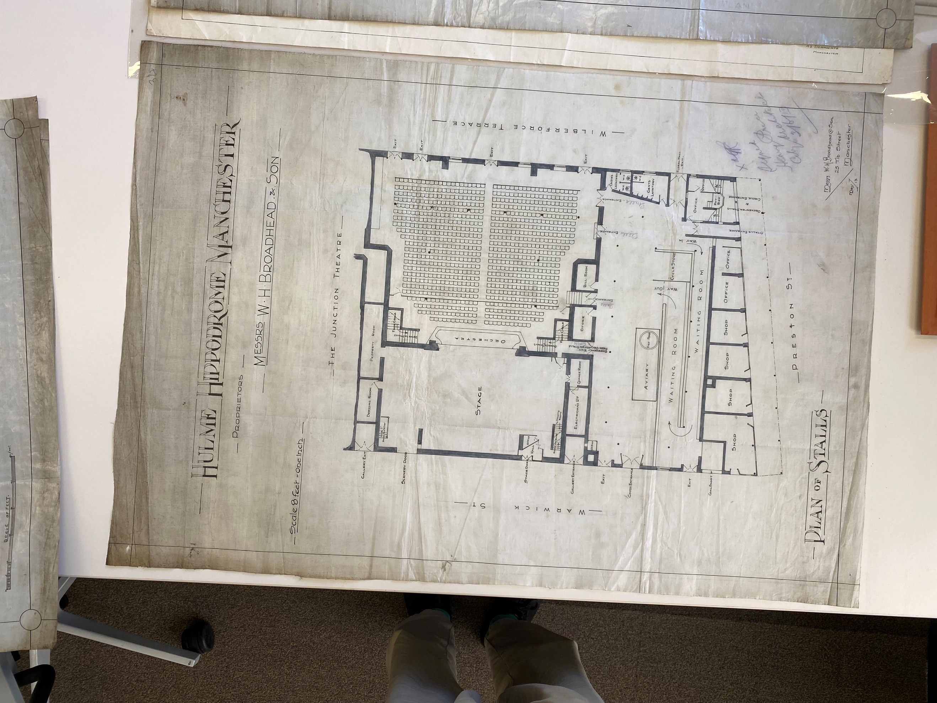
------------------------------------ 36m ----------------------------------------------------------------------------------
--------------- 13.4m ------------------

